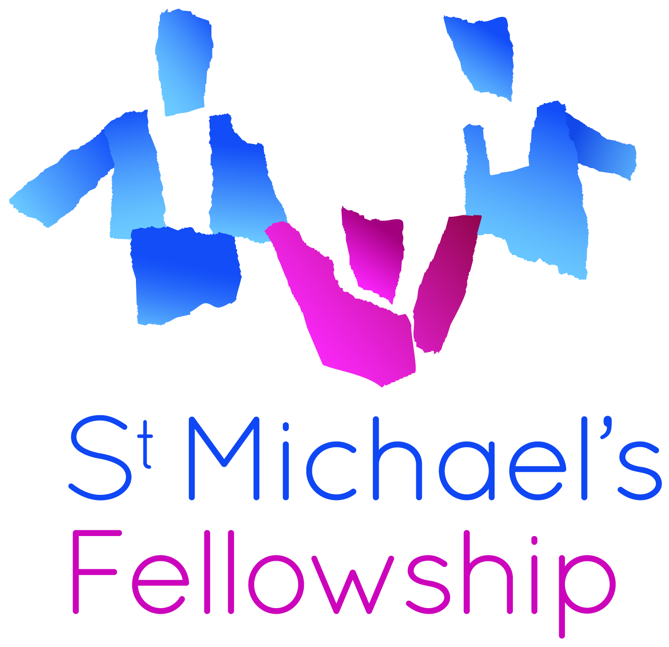
136 Streatham High Road
London SW16 1BW
T. 020 8835 9570
F. 020 8677 4883
admin@stmichaelsfellowship.org.uk
www.stmichaelsfellowship.org.uk

EQUAL OPPORTUNITIES

St. Michael’s affirms the principles contained in the United Nations Declaration of the Rights of the Child. We recognise the inherent dignity and the equal and inalienable rights of all members of the human family without distinction and without discrimination of any kind, recognising and valuing differences in the child’s or his or her parent’s, legal guardian’s or other carer’s race, colour, gender, sexual orientation, language, religion, political, or other opinion, national ethnic or social origin, property, disability, birth or other status. We believe in the promotion of the common good and the achievement of natural and social justice.

EQUAL OPPORTUNITIES INFORMATION

This information is for monitoring purposes only and will not be used in the selection process.

Post applied for: Click here to enter text.

Gender: Male ☐ Female ☐

Age: Click here to enter text.

Health:
Do you have a health need or disability which requires special facilities in the workplace? ☐

If yes, please describe Click here to enter text.

Racial Group:
Please indicate which of the following racial groups you belong to:
(Classifications recommended by the CRE)

☐ White British ☐ Black – other background
☐ White Irish ☐ Bangladeshi
☐ White – other background ☐ Chinese
☐ White and Black Caribbean ☐ Indian
☐ White and Black African ☐ Pakistani
☐ White and Asian ☐ Any other Asian background
☐ Any other mixed background ☐ Other ethnic origin
(Please specify ………………….)
☐ Black – African ☐ Not stated
☐ Black - Caribbean

Dependants:
Are you responsible for dependants? ☐

Where did you see this post advertised? Click here to enter text.

