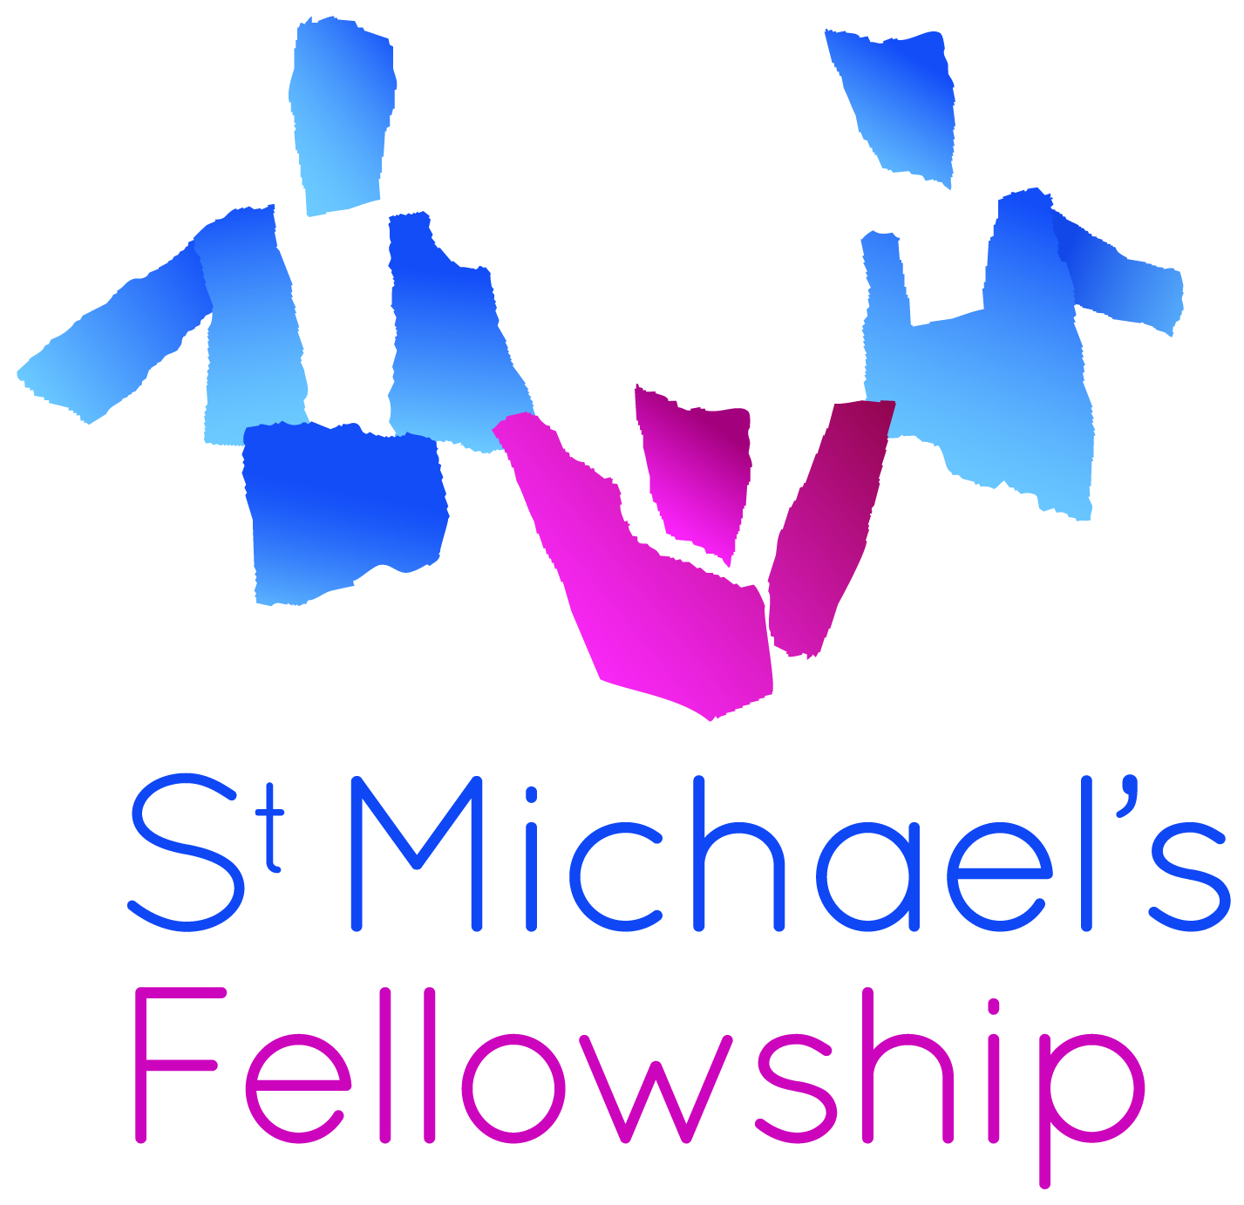
136 Streatham High Road
London SW16 1BW
T. 020 8835 9570
F. 020 8677 4883
admin@stmichaelsfellowship.org.uk
www.stmichaelsfellowship.org.uk

OUTREACH REFERRAL FORM

St Michael’s Fellowship offers practical and emotional support to young parents and parents–to-be (mums and dads aged 24 and under) living in Lambeth. The service consists of a wide range of individual and group outreach support tailored to parents’ and children’s personal needs.

Text boxes will expand as you type

Young mother’s support ☐ Young father’s support ☐

Name of Referrer: Click here to enter text. Agency: Click here to enter text.

Phone: Click here to enter text. Email: Click here to enter text.

What support does this young parent require? Individual Support ☐ Group Support ☐

Young parent / parent-to-be

Name Click here to enter text. Date of Birth Click here to enter a date.

Address: Click here to enter text. Phone: Click here to enter text.

Ethnicity (classification recommended by CRE): Choose an item. 1st Language Click here to enter text.
Smoker? Choose an item.

Next of Kin Name: Click here to enter text Phone: Click here to enter text.

Second Parent / Parent to be Name: Click here to enter text. Date of Birth Click here to enter a date.
Address: Click here to enter text. Phone: Click here to enter text. Smoker: Choose an item.

Name of first child: Click here to enter text. Date of birth / due date Click here to enter a date.
Name of second child: Click here to enter text. Date of birth / due date Click here to enter a date.

What contraception was used? Click here to enter text. Existing CAF? Choose an item.

If YES may the St Michael’s Young Fathers Social Worker contact the father direct? Choose an item.

Reason for referral box will expand as you type …

Do you know of any other support needs, challenges or concerns regarding this family? (Check all applicable)

Lacks parenting skills ☐ Mental Health ☐ Special Needs ☐ Child Protection ☐
Education/training ☐ Young Offender ☐ Smoking ☐ Substance Misuse ☐
Asylum/Refugee ☐ Housing ☐ No Recourse ☐ Looked After ☐
Domestic Abuse ☐ Care Leaver ☐ Childcare ☐ Other please give brief details

Agency Contacts
Social Worker Name Click here to enter text. | Phone Click here to enter text.
Health Visitor Name Click here to enter text. | Phone Click here to enter text.
GP Name Click here to enter text. | Phone Click here to enter text.
Midwife Name Click here to enter text. | Phone Click here to enter text.
Other Agency Click here to enter text. | Phone Click here to enter text.

Is the young person aware of this referral? Choose an item.

Has the young person given their permission to share the information above? Choose an item.

Signed: Click here to enter text. Date: Click here to enter a date.
Your electronic signature is acceptable

HOME RISK ASSESSMENT

St. Michael’s often work in clients’ homes. It is vital that we are told of any known or suspected factors that could put us in danger. Please fill in the following risk assessment.

1. Where did you first meet the client?

Home ☐ Office ☐ Clinic ☐ Group ☐ Public Place ☐ Children’s Centre ☐ Other please explain

2. Did the client display any inappropriate behaviour? Choose an item.

Shouting ☐ Swearing ☐ Shaking/Trembling ☐ Threatening Behaviour ☐ Agitated Behaviour ☐

If YES please give brief details box will expand as you type …

3. Do you know of any violent or aggressive incidents involving this client (eg criminal, domestic violence)?
Choose an item.
If YES please give details box will expand as you type …

4. Are you aware of any pets in the home? Choose an item.

If YES which animal(s)? Click here to enter text.

5. Would you advise a joint initial home visit? Choose an item.

If YES please explain why. box will expand as you type …

6. Please give any other information we should know regarding home visits.

box will expand as you type …

Return the completed form to admin@stmichaelsfellowship.org.uk ref Young Parent Referral

